Guided Capstone Report

Introduction:

In this project we had a list of attributes that would be useful to predict the prices in order to achieve profits. Meanwhile, most of the columns in the dataset don't have high cardinality and fastEight columns have the most repetitive data when compared to other columns.

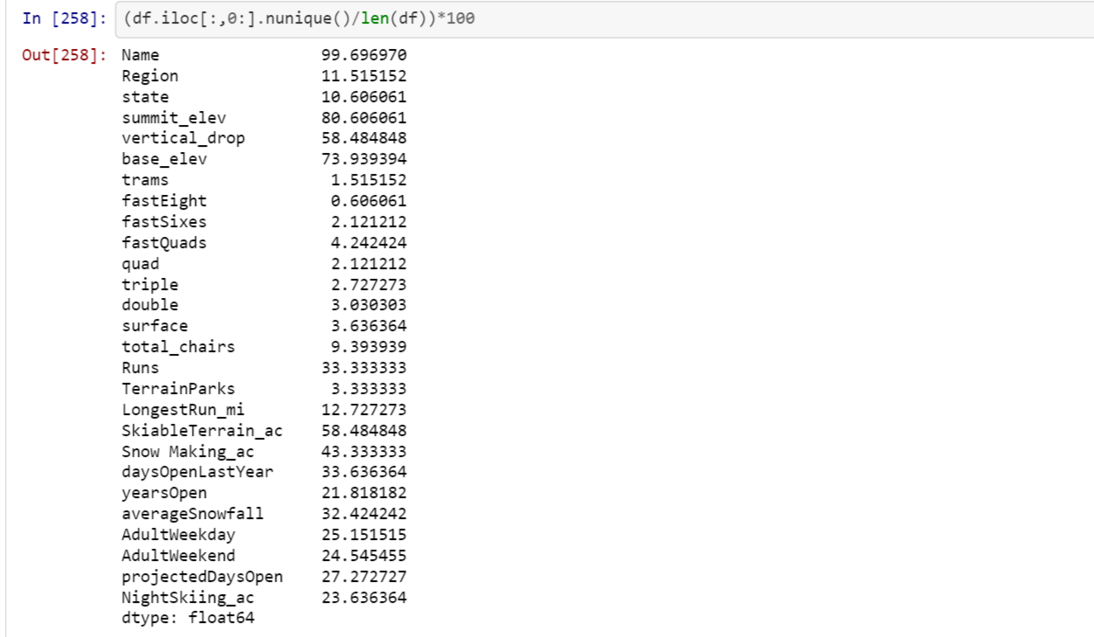

In the second step we had tried to identify the missing values and tried to calculate whether there were any mathematical calculations to fill the missing values. So, we had identified that fastEight missing values can be filled by adding the surfaces provided by all chairs and subtracting it with the total_chairs columns. Even after filling the fight_Eight column we had identified that there were some columns with missing values. We had tried to calculate any relations with other columns to fill the missing values but we couldn’t visualize any patterns among them. So, we had tried to fill the missing values with help of mean which is one of the best ways to fill missing data.

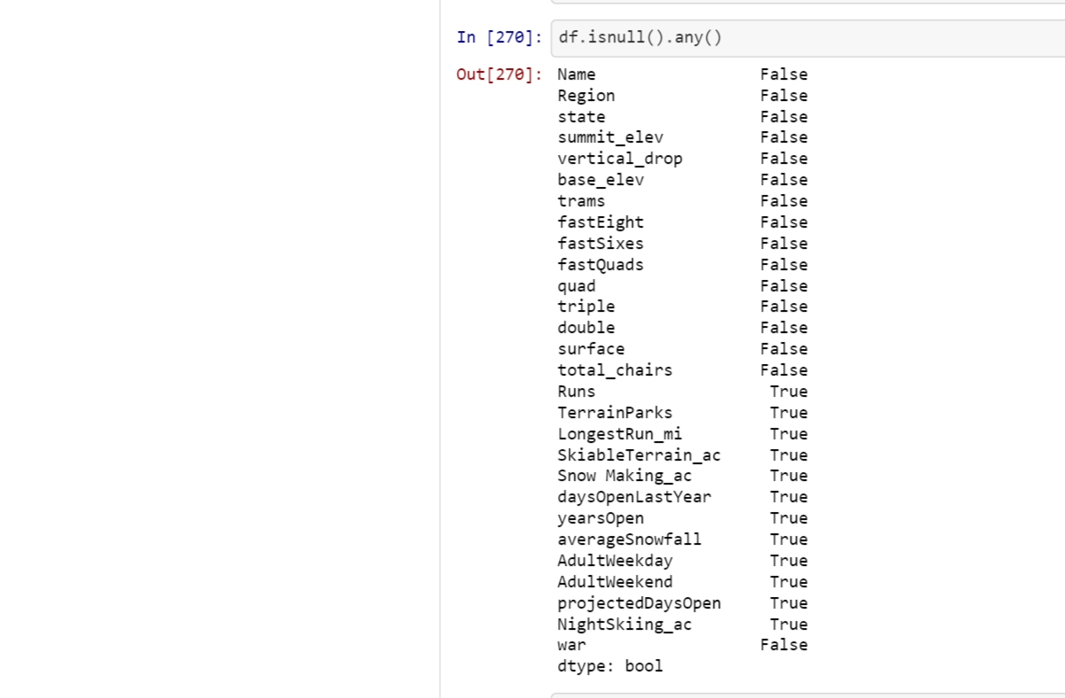

After all, completing all the steps by implementing lmplot on AdultWeekend,AdultWeekday we had analyzed that with increasing in price there’s an increase in projectedDaysOpen.

